Detailed tutorial of how to reuse codes
Prerequisites
1. Hardware Requirements
- CPU: Intel i5 or above
- Memory: 8GB or above
- GPU (optional but recommended): GTX 1060 or above (if run ERNIE-Bot 4.0, ERNIT-Bot-turbo, GPT-4, or GPT-3.5-turbo), GTX 4090 (if run Qwen-7B-Chat, Baichuan2-7B-Chat, or ChatGLM3-6B), L40 (if run Qwen-14B-Chat or Baichuan2-13B-Chat)
2. Software Requirements
- Python 3.9 or above
- PyTorch 1.9 or above

Step-by-step Guide
Step 1: Downloading supplementary materials (e.g., CEM-EKB, codes, and CEM-QA test dataset) provided by this study through the URL [https://github.com/0AnonymousSite0/QA_for_CEM] 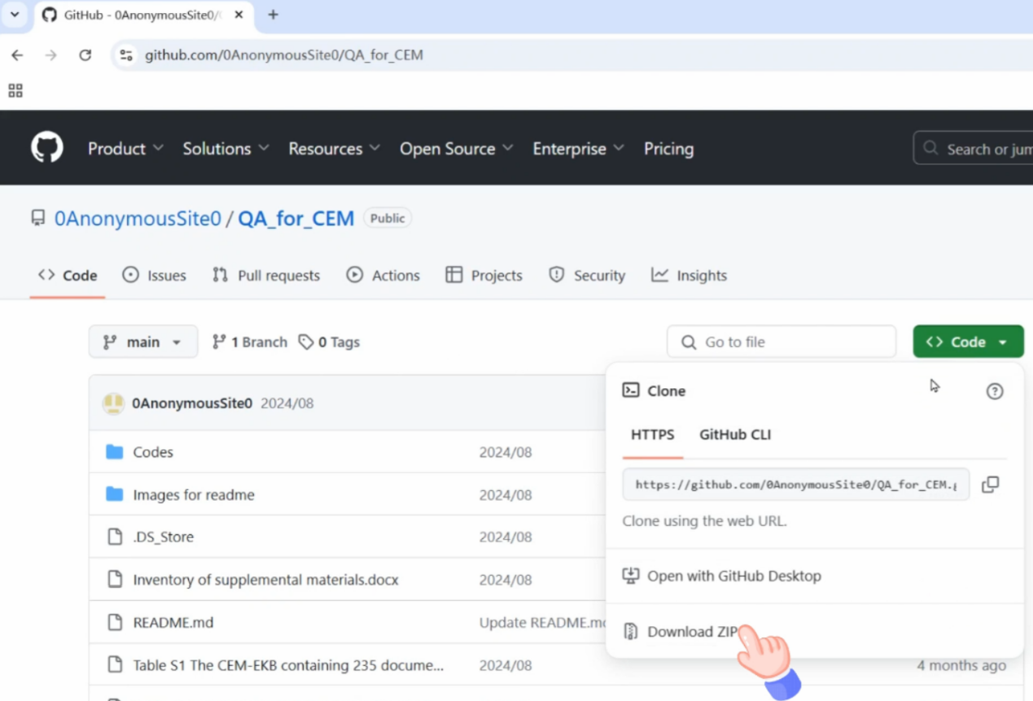
Step 2: Configuring the environment
Enter pip install -r requirements.txt in the Terminal
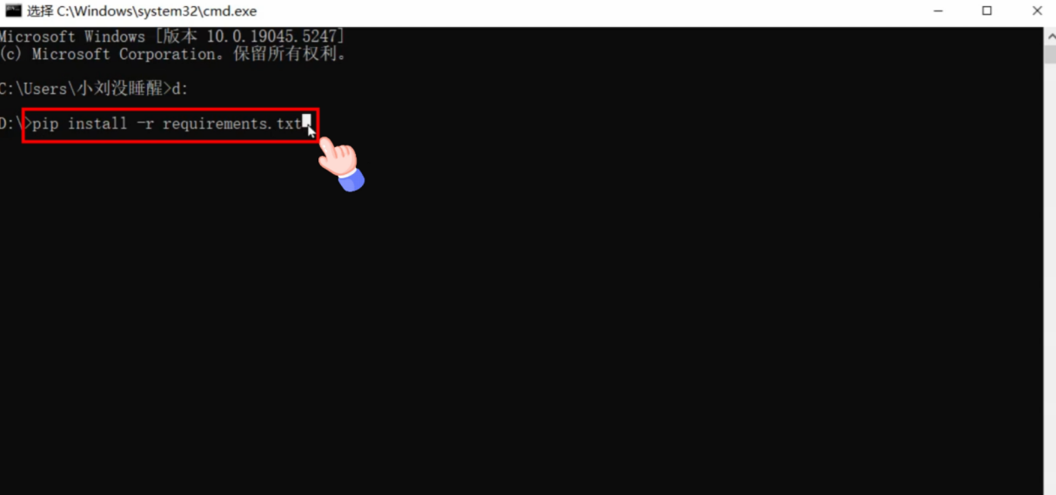

Step 3: Modifying codes (using knowledge-incorporated fine-tuned GPT-3.5-turbo as an example)
- Replace the string in the line 4 with the actual OpenAI API key value
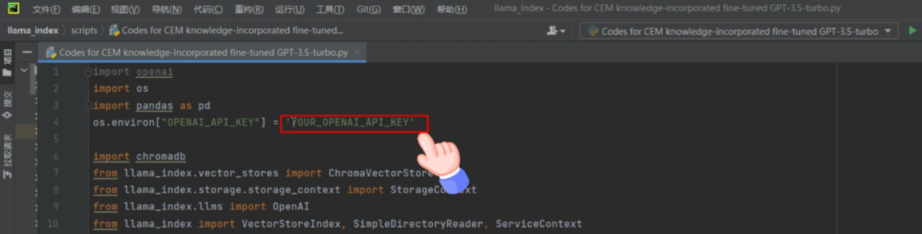
- Replace the string in the line 12 with the actual path to the CEM-EKB
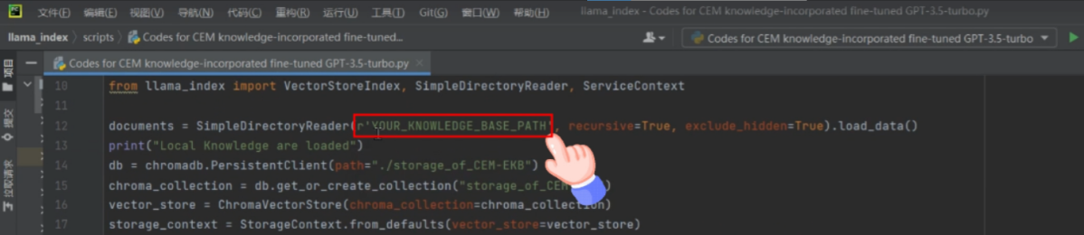
- Replace the string in the line 19 with the actual path fine-tuned model ID
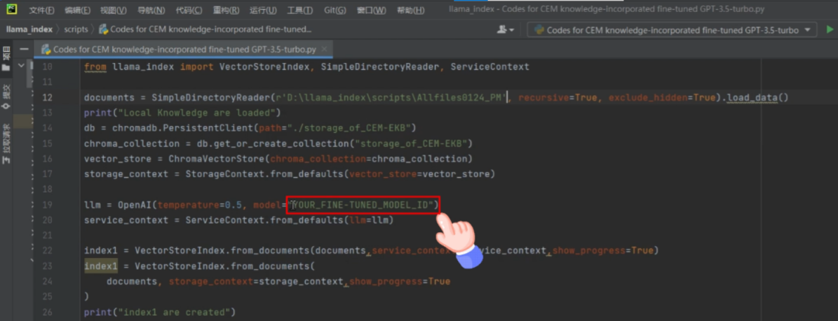
- If loading the CEM-EKB for the first time, it is needed to run the code from lines 22 to 26, and comment out the code from lines 27 to 31.
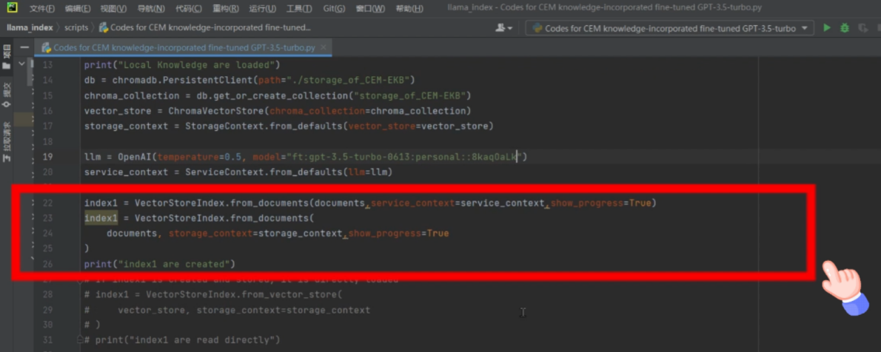
- If it is not the first time loading the CEM-EKB, it is needed to run the code from lines 27 to 31, and comment out the code from lines 22 to 26.
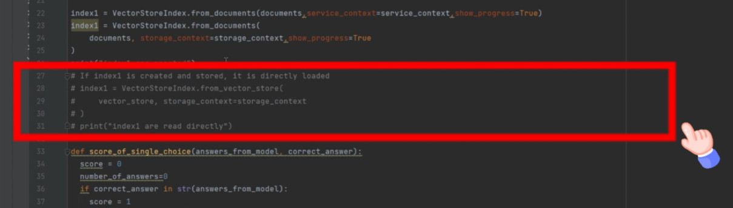
- Replace the string in the line 94 with the actual test dataset file names
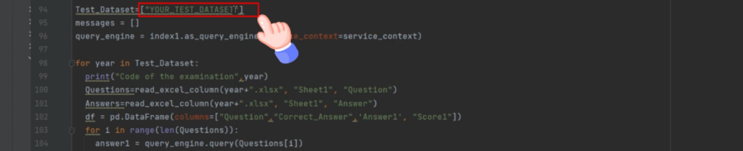
Step 4: Running codes


